Afghanistan in Focus

* 1ST APRIL 2019

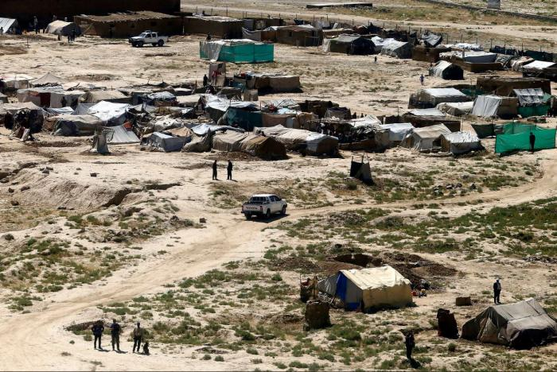

***Today, the European Asylum Support Office (EASO) published a Country of Origin Information (COI) Report entitled***[***'Afghanistan Key socio-economic indicators. Focus on Kabul City, Mazar-e Sharif and Herat City***](https://coi.easo.europa.eu/administration/easo/PLib/EASO_COI_Afghanistan_KSEI_April_2019.pdf)***'. In 2018, Afghanistan ranked second in the top countries of origin in EU+ countries1, with 45 300 applicants.***

The report is an update of a similar EASO COI report published in 2017. It provides a general description of the socio-economic situation in Afghanistan, for the country as a whole, and where available for the three cities – Kabul, Mazar-e Sharif and Herat – separately covering the following topics: economic growth; employment; poverty; food security; access to education; health care; housing. Travel into these three cities has also been researched by looking into travel restrictions or requirements in Afghanistan and ways of travelling by domestic air traffic. Additional attention is paid to specific groups such as IDPs, returnees, women and children.

The report was co-drafted by COI researchers from the national asylum authorities of Finland and Romania in accordance with the [EASO COI Report Methodology](https://coi.easo.europa.eu/administration/easo/PLib/EASO_COI_Report_Methodology.pdf). The report was reviewed by COI researchers from Denmark, Luxembourg and the Netherlands, EASO, and UNHCR. In addition, a review of the report was carried out by Fabrizio Foschini, analyst from the Afghanistan Analysts Network.

The terms of reference of this report were defined by EASO-based information needs identified by asylum policy experts in EU+ countries and UNHCR. It is EASO's intention to continue to produce such reports on important countries of origin and to update them regularly in order to raise and harmonise COI standards in the EU and to further support the practical implementation of the Common European Asylum System.

A further update of the EASO [COI Report Afghanistan – Security Situation](https://coi.easo.europa.eu/administration/easo/PLib/Afghanistan-security_situation_2018.pdf) (May 2018) is expected shortly.